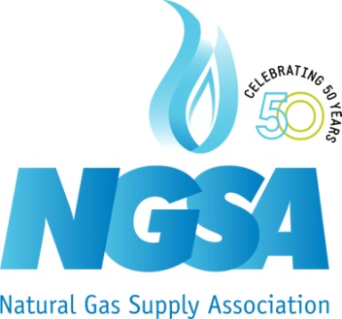

NEWS
For Immediate Release: July 30, 2015
Contact: Daphne.Magnuson@ngsa.org (202) 326-9300
Sending on behalf of Daphne Magnuson

NGSA Statement on Senate Energy Committee Bill
Committee Proposes Improved LNG Export Process in Energy Bill

(Washington, DC) The Natural Gas Supply Association (NGSA) today praised the Senate Energy Committee for its bipartisan approval of language that improves the LNG export decision making process as part of a comprehensive energy bill. The proposed legislation establishes a deadline for the Energy Department to make a decision on export applications.

Dena E. Wiggins, president and CEO of NGSA said:

“We commend the Senate Energy Committee for voting to make the LNG export approval process more efficient and timely. Streamlining the approval process for LNG export applications from the United States can create tens of thousands of American jobs and reduce global greenhouse gas emissions, while preserving a competitive advantage for American manufacturers. With the bill next headed to the Senate, we urge the Senate to vote in favor of legislation expediting the LNG export process.”

- NGSA–

The Natural Gas Supply Association (NGSA) represents integrated and independent companies that supply natural gas. Established in 1965, NGSA encourages the use of natural gas within a balanced national energy policy, and promotes the benefits of competitive markets, thus encouraging increased supply and the reliable and efficient delivery of natural gas to U.S. customers. For more information, please visit www.ngsa.org and www.naturalgas.org.

Markets Matter: Representing America’s Major Producers and Suppliers of Natural Gas Since 1965

